2019 Washington Lichen Species
of Special Concern and Review Lists

Washington Natural Heritage Progam
DRAFT December 17, 2019

WASHINGTON NATURAL HERITAGE PROGRAM
Natural Heritage
Report 2019-04

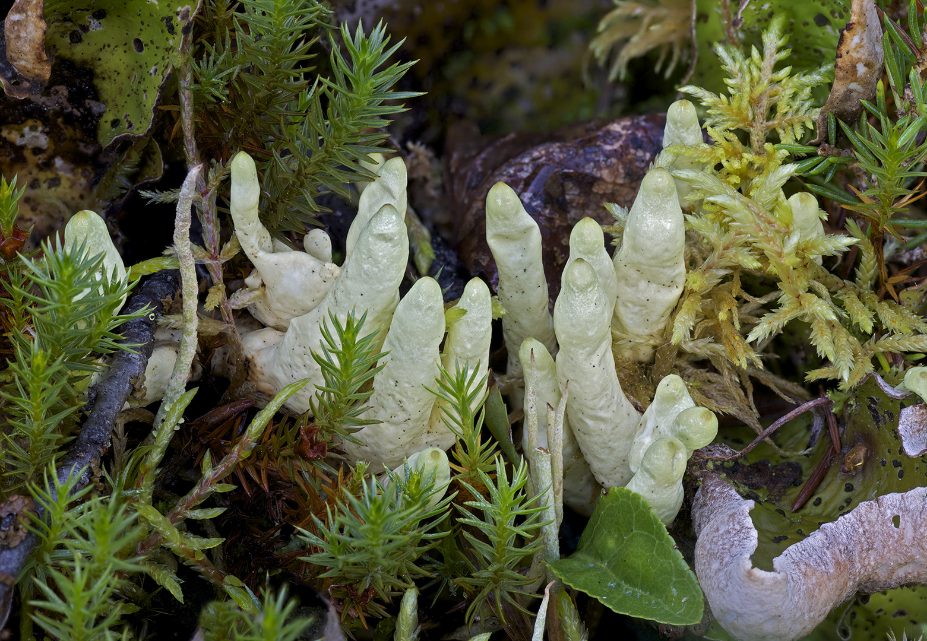

2019 Washington Vascular Lichen Species of Special Concern and Review Lists

Washington Natural Heritage Program Report Number: 2019-xx
December 17, 2019

Washington Natural Heritage Program
Washington Department of Natural Resources
Olympia, Washington 98504-7014

ON THE COVER: Arctic datylina lichen (Dactylina arctica) known from Okanogan and Skamania counties, from Whitman Co., Washington

Photograph by: Richard Droker (with permission).from St. Elias Lake Trail, Yukon, Canada.
.

Table of Contents
Page
Table of Contents ii
Introduction 1
Washington Lichen Species of Special Concern 5
Washington Lichen Review List 1………………………………………………………………...9
Washington Lichen Review List 2………………………………………………………………10
Literature Cited 11
Acknowledgments 11

Introduction

For more than 40 years the Washington Natural Heritage Program (WNHP) has maintained a list of Washington plant species of conservation concern. Each of these species is ranked at the global and state scale following the standardized protocol of the NatureServe network. Although WNHP is not a regulatory agency, the program’s list and rankings help inform conservation decisions relating to rare plants on federal, state, private, and tribal lands (WDNR 2018).

In 2011, Northwest Lichenologists (a non-profit organization promoting research and appreciation of lichens in northwestern North America) obtained a grant from the US Forest Service and Bureau of Land Management to conduct a review of the conservation status of lichens in Washington. The goal of the project was to make recommendations to WNHP of lichen species that are Endangered, Threatened, or Sensitive in the state. This list was submitted in February 2013 (Northwest Lichenologists 2013), but was not formally adopted by WNHP until 2018.

The following report is an update of the 2013 list. Additional information is provided on distribution pattern within Washington (local endemic, peripheral, disjunct, etc.) and by county, ecoregion, and major managed area (such as national forest, national park, or state lands). The list is divided into three parts: species of special concern (taxa listed as state endangered, threatened, sensitive, or extirpated); Review 1 (species under consideration for potential state listing but which need more information); and Review 2 (species under consideration or potential state listing, but have taxonomic questions that need to be resolved).

Each of the main headings in the species list and their codes are briefly described below:

Species/Common Name: Species are organized alphabetically by their scientific name. Nomenclature mostly follows the Consortium of North American Lichen Herbaria (2019). Pertinent synonyms are included in parentheses. Common names follow the USDA Plants database (http://plants.usda.gov) or NatureServe (http://explorer.natureserve.org).

Heritage Rank: WNHP uses the ranking system developed by NatureServe to assess global and state conservation status of each plant species, subspecies, and variety. Taxa are ranked on a scale of 1 to 5 (from highest to lowest conservation concern).

G = Global Rank: rangewide status of a full species
T = Trinomial Rank: rangewide status of a subspecies or variety
S = State Rank: status of a species, subspecies, or variety within the state of Washington

1 = Critically Imperiled – at very high risk of extirpation due to very restricted range,
very few occurrences, very steep declines, very severe threats, or other factors
2 = Imperiled – at high risk of extirpation due to restricted range, few occurrences, steep
declines, severe threats, or other factors
3 = Vulnerable – at moderate risk of extirpation due to a fairly restricted range, relatively
few occurrences, recent and widespread declines, threats, or other factors
4 = Apparently secure – at fairly low risk of extirpation due to an extensive range or
many occurrences, but with possible cause for some concern as a result of local
recent declines, threats, or other factors
5 = Secure – at very low risk of extirpation due to a very extensive range, abundant
occurrences, and little to no concern from decline or threats
H = Historical– known from only historical occurrences (prior to 1978) but still with
some hope of rediscovery
X = Presumed Extirpated – not relocated since 1978 despite intensive searches and
virtually no likelihood of rediscovery
U = Unrankable – lack of information or substantially conflicting information about
status
NR = Not Ranked – rank not assessed yet
Q = Questionable - questions exist about the taxonomic validity of a species, subspecies,
or variety
? = Questionable – questions exist about the assigned G, T, or S rank of a taxon

State Status: Washington state status is assigned by WNHP. Factors considered include abundance, distribution patterns, number of extant occurrences, vulnerability, threats, existing protection, and taxonomic distinctness. Categories include:
Endang = Endangered, in danger of becoming extinct or extirpated from Washington Threat = Threatened, likely to become Endangered in Washington
Sens = Sensitive, vulnerable or declining and could become Threatened or Endangered in
Washington
Extirp = possibly extinct or extirpated in Washington (includes state historical species)
Federal Status: No lichens in Washington are currently listed or candidates for listing under the US Endangered Species Act.
The Interagency Special Status and Sensitive Species Program (ISSSSP) of the US Forest Service (USFS) and Bureau of Land Management (BLM) in Washington and Oregon recognize two categories of species of concern (ISSSSP 2019).

B-Sens = BLM Sensitive; all USFWS candidate and delisted species and WNHP species
of concern ranked S1, S1S2, S1S3, S2, or S2S3 found on at least one BLM
managed area in Washington.
F-Sens = Forest Service Sensitive: all USFWS candidate and delisted species and
WNHP species of concern ranked S1, S1S2, S1S3, S2, or S2S3 found on at least
one USFS managed area in Washington.

Distribution (Dist.) Pattern: Species rarity is often correlated with geographic distribution patterns. The following patterns can be recognized in Washington:
LocEnd = Local Endemic; global range of taxon is less than 16,500 km² or about 1
degree of latitude x 2 degrees of longitude (about the size of an average county)
RegEnd = Regional Endemic; global range of taxon is between 16,500 to 250,000 km²
(or an area about the size of the state of Washington)
Disjunct = Disjunct; globally widespread but state population is isolated from the main
contiguous range by a gap or more than 500 km
Periph = Peripheral; globally widespread but Washington population is at the margin of
the main contiguous range of the taxon
Sparse = Sparse; widely distributed across the state but with relatively few populations
(less than 20)
Widesp = Widespread; widely distributed globally and in Washington, with more than 20
populations in the state.

County: Three-letter codes are used to document the distribution of plant species by county. Vague or unsubstantiated reports are indicated by ?.
Ada = Adams Grh = Grays Harbor Pie = Pierce
Aso = Asotin Isl = Island Saj = San Juan
Ben = Benton Jef = Jefferson Skg = Skagit
Che = Chelan Kin = King Skm = Skamania
Clm = Clallam Ktp = Kitsap Sno = Snohomish
Clk = Clark Ktt = Kittitas Spo = Spokane
Col = Columbia Kli = Klickitat Ste = Stevens
Cow = Cowlitz Lew = Lewis Thu = Thurston
Dou = Douglas Lin = Lincoln Whk = Wahkiakum
Fer = Ferry Mas = Mason Waw = Walla Walla
Fra = Franklin Oka = Okanogan Whc = Whatcom
Gar = Garfield Pac = Pacific Wht = Whitman
Gra = Grant Peo = Pend Oreille Yak = Yakima

Ecoregion: Ecoregions are biologically-defined geographic areas with similar environmental, physiographic, or vegetation patterns. We follow the classification of Camp and Gamon (2011). Two-letter codes are used for ecoregion names. Vague or unsubstantiated reports are indicated by ?.
BM = Blue Mountains EC = East Cascades PC = Pacific Northwest Coast
CP = Columbia Plateau NC = North Cascades PT = Puget Trough
CR = Canadian Rockies OK = Okanogan WC = West Cascades
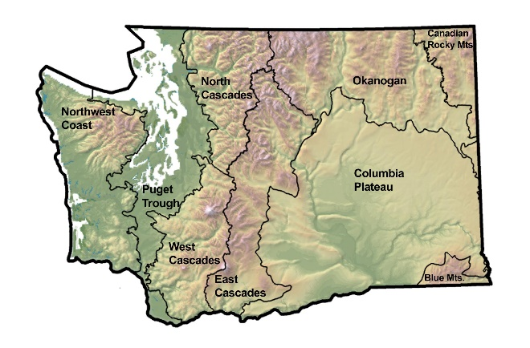
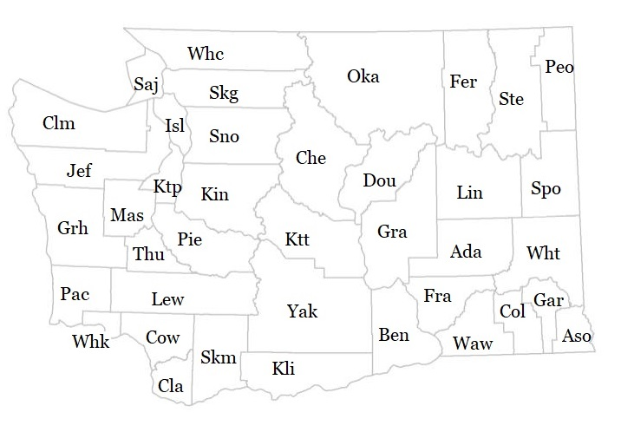
Washington Counties Washington Ecoregions

Managed Area: Major Washington state, federal, or tribal land management areas are included when known. Blank listings indicate that a species is only known from private lands or state trust lands. “? “indicates that presence within a management area is not confirmed. Complete managed area information, or data specific to individual plant occurrences, can be obtained from WNHP (www.dnr.wa.gov/natural-heritage-program). The following abbreviations are used:
BLM = Bureau of Land Management
NAP = Natural Area Preserve (Washington Dept of Natural Resources)
NF = National Forest
NP = National Park
NRCA = Natural Resources Conservation Area (Washington Dept of Natural Resources)
NSA = National Scenic Area
NVM = National Volcanic Monument
NWR = National Wildlife Refuge
SP = State Park
SWA = State Wildlife Area (Washington Dept of Fish & Wildlife)
WA = Wilderness Area

Washington Lichen Species of Special Concern
Washington Species of Special Concern
Species  Common Name | Heritage Rank | State Status | Federal Status | Dist. Pattern | County | Eco-region | Managed Area
Acroscyphus sphaerophoroides  crab eye lichen | GNR/S1 | Endang |  | Periph | Sno | NC | Glacier WA  Mt. Baker-Snoqualmie NF
Alectoria nigricans  (Gowardia nigricans)  witch’s hair lichen | G5/S3 | Threat |  | Wide | Che, Clm, Lew, Oka, Pie, Skg, Skm, Whc | EC, NC, OK, PC, WC | Gifford Pinchot NF  Mt. Baker-Snoqualmie NF  Mt. Rainier NP  Okanogan-Wenatchee NF  Olympic NP  Tatoosh WA
Alectoria ochroleuca  green witch’s hair lichen | G5/S1 | Endang |  | Sparse | Clm | PT
Arctoparmelia incurva  arctoparmelia lichen | G5/S1 | Endang | F-Sens | Sparse | Oka, Yak | EC, OK | Gifford Pinchot NF  Mt. Adams WA  Okanogan-Wenatchee NF
Bryoria tenuis  (Alectoria t., Bryopogon t.)  pied horsehair lichen | G3G5/S1 | Endang |  | Periph | Saj | PT | Moran SP
Bunodophoron melanocarpum  (Sphaerophorus compressus)  northern fan-coral lichen | GNR/S1 | Threat |  | Periph | Clm, Jef | PC | Olympic NP
Catolechia wahlenbergii  Wahlenberg's catolechia lichen | G3G5/S1 | Endang |  | Disj | Lew | WC | Mt. Rainier NP
Chaenotheca subroscida  needle lichen | G3G4/S3 | Sens |  | Wide | Gar, Ktt, Oka, Ska, Yak | BM, EC, OK, WC | Gifford Pinchot NF  Okanogan-Wenatchee NF  Umatilla NF
Cladonia ciliata var. ciliata  cup lichen | GNR TNR/S1 | Endang |  | Disj | Thu | PT | Mima Mounds NAP  Scatter Creek SWA
Cladonia ciliata var. tenuis  cup lichen | GNR TNR/S1 | Endang |  | Disj | Thu | PT | Glacial Heritage Preserve  Mima Mounds NAP  Scatter Creek SWA  South Puget Prairie Preserve
Cladonia novochlorophaea  novochlorophaeic pixie-cup lichen | G5T1/S1 | Endang |  | Disj | Thu | PT | Glacial Heritage Preserve  Mima Mounds NAP  Scatter Creek SWA
Cladonia poroscypha  perforate pixie cup | GNR/S1 | Endang |  | RegEnd | Isl, Skg | PT | Deception Pass SP
Cladonia portentosa ssp. pacifica  maritime reindeer lichen | G5TNR/S2 | Threat |  | RegEnd | Pac, Skg, Thu | PC, PT | Glacial Heritage Preserve  Leadbetter Point SP  Mima Mounds NAP  Scatter Creek SWA  South Puget Prairie Preserve  Washington Park
Collema nigrescens  jelly lichen | G5?/S3 | Sens |  | Sparse | Lew, Peo, Pie, Skm, Thu | CR, PT, WC | Bald Hill NAP  Columbia River Gorge NSA  Colville NF  Gifford Pinchot NF  Mt. Baker-Snoqualmie NF  Mt. St. Helens NVM
Dactylina arctica  arctic dactylina lichen | G5/S1 | Endang | F-Sens | Disj | Oka, Skm | OK, WC | Gifford Pinchot NF  Okanogan-Wenatchee NF
Dactylina ramulosa  dactylina lichen | G5/S1 | Endang |  | Periph | Oka | OK | Okanogan-Wenatchee NF  Pasayten WA
Washington Species of Special Concern
Species  Common Name | Heritage Rank | State Status | Federal Status | Dist. Pattern | County | Eco-region | Managed Area
Dermatocarpon meiophyllizum  silverskin lichen | G3G5/S2 | Threat | B-Sens  F-Sens | Sparse | Che, Ktt, Lin, Oka, Skm | CP, EC, OK, WC | Alpine Lakes WA  Gifford Pinchot NF  Mt. St. Helens NVM  Okanogan-Wenatchee NF  Pasayten WA  Spokane BLM
Dermatocarpon moulinsii  Moulins' silverskin lichen | GNR/S1 | Endang |  | Sparse | Whc | NC | Mt. Baker-Snoqualmie NF
Erioderma sorediatum  erioderma lichen | G4/S2 | Threat | B-Sens  F-Sens | Periph | Clm, Jef, Pac | PC | Leadbetter Point SP  Olympic NP
Fuscopannaria laceratula  torn shingles lichen | G5/S1 | Endang |  | Periph | Clm | PC | Olympic NP
Heterodermia leucomela  shield lichen | G4/S1 | Endang |  | Periph | Jef, Pac | PC | Cape Disappointment SP  Olympic NF
Hypogymnia heterophylla  tube lichen | G3/S3 | Sens |  | Sparse | Pac, Thu | PC, PT | Bald Hill NAP  Cape Disappintment SP
Hypotrachyna revoluta  hypotrachyna lichen | G3G4/S1 | Endang |  | Periph | Skg, Skm | NC, WC | Beacon Rock SP  Columbia River Gorge NSA  Mt. Baker-Snoqualmie NF
Kaernefeltia californica  kaernefeltia lichen | G3/S2 | Threat |  | Sparse | Grh | PC | Westport Lighthouse SP
Leioderma sorediatum  treepelt lichen | G4/S1 | Endang | B-Sens  F-Sens | Periph | Clm | PC | Olympic NP
Leptogium burnetiae  Burnet's skin lichen | G4G5/S1 | Endang | B-Sens  F-Sens | Sparse | Skm, Sno | NC, WC
Leptogium cyanescens  skin lichen | G5/S1 | Endang | F-Sens | Periph | Skm, Sno | NC, WC | Columbia River Gorge NSA  Gifford Pinchot NF  Mt. Baker-Snoqualmie NF  Wild Sky WA
Nephroma occultum  kidney lichen | G4/S3 | Sens |  | Wide | Lew, Oka, Peo, Skm, Sno, Whc | CR, NC, OK, WC | Colville NF  Gifford Pinchot NF  Mt. Baker-Snoqualmie NF  Mt. St. Helens NVM  Okanogan-Wenatchee NF
Niebla cephalota  niebla lichen | G3G4/S2 | Sens | B-Sens  F-Sens | Disj | Clm, Isl, Saj, Skg | PT | Deception Pass SP  San Juan NHP  Sequim Bay SP  Spokane BLM
Pannaria rubiginella  shingle lichen | G3G5/S1 | Endang |  | Periph | Jef | PC | Olympic NP
Peltigera hydrothyria  (Hydrothyria venosa, H. fontana)  hydrothyria lichen | G4/S3 | Sens |  | Wide | Che, Cow, Lew, Skm, Sno | EC, NC, WC | Gifford Pinchot NF  Glacier Peak WA  Mt. Adams WA  Mt. Baker-Snoqualmie NF  Mt. St. Helens NVM  Okanogan-Wenatchee NF
Pertusaria coccodes  black-spotted wart lichen | GNR/S1 | Endang |  | Disj | Clm | PC
Pseudocyphellaria hawaiiensis  (P. perpetua)  gilded specklebelly lichen | G5/S1 | Endang | F-Sens | Disj | Grh | PC | Olympic NF
Pseudocyphellaria rainierensis  Rainier pseudocyphellaria lichen | G3G4/S4 | Sens |  | RegEnd | Grh, Jef, Kin, Lew, Pie, Skg, Skm, Sno, Whc | NC, PC, WC | Gifford Pinchot NF  Glacier Peak WA  Mt. Baker-Snoqualmie NF  Mt. Rainier NP  Mt. St. Helens NVM  Olympic NF
Washington Species of Special Concern
Species  Common Name | Heritage Rank | State Status | Federal Status | Dist. Pattern | County | Eco-region | Managed Area
Ramalina pollinaria  powdery twig lichen | G4/S2 | Threat |  | Periph | Clm, Grh, Isl, Saj, Skg, Sno | PC, PT | Deception Pass SP  Dungeness NWR  Obstruction Pass SP  Spokane BLM
Ramalina thrausta  cartilage lichen | G5/S2 | Threat | B-Sens  F-Sens | Sparse | Lew, Pac, Peo | CR, PC, WC | Colville NF  Fort Columbia SP  Gifford Pinchot NF
Solorina saccata  chocolate chip lichen | G5/S1 | Endang | B-Sens  F-Sens | Periph | Peo, Skg, Whc | CR, NC | Colville NF  Mt. Baker-Snoqualmie NF  Mt. Baker WA  North Cascades NP
Stereocaulon myriocarpum  snow lichen | G4/S2 | Threat |  | Sparse | Kli | EC
Sulcaria badia  groovy beard lichen | G3/SH | Extirp |  | Disj | Clm | PT
Sulcaria spiralifera  (Bryoria pseudocapillaris, B. spiralifera)  horsehair lichen | G3/S1 | Endang |  | Disj | Clm, Isl | PC, PT | Deception Pass SP  Olympic NP
Texosporium sancti-jacobi  woven-spore lichen | G3/S1? | Threat | B-Sens  F-Sens | Periph | Ben, Kli, Yak | CP | Cleveland Shrub Steppe NAP  Spokane BLM
Thelomma mammosum  thelomma lichen | G3G4/S2 | Sens | B-Sens | Periph | Isl, Saj, Skg | PT | Cattle Point NRCA  Deception Pass SP  Spokane BLM
Tholurna dissimilis  urn lichen | G4G5/S2 | Sens | B-Sens  F-Sens | Sparse | Che, Clm, Kin, Lew, Oka, Pie, Skm, Sno, Whc | EC, NC, OK, PC, WC | Alpine Lakes WA  Gifford Pinchot NF  Glacier Peak WA  Henry M. Jackson WA  Mt. Baker-Snoqualmie NF  Mt. Baker WA  Okanogan-Wenatchee NF  Olympic NP  Pasayten WA
Umbilicaria lambii  Lamb's navel lichen | G2G4/S1 | Endang | F-Sens | RegEnd | Jef, Lew, Skm | PC, WC | Gifford Pinchot NF  Mt. St. Helens NVM  Olympic NP  Tatoosh WA
Umbilicaria lyngei  Lynge's navel lichen | G3/S1 | Endang |  | Sparse | Pie, Whc | NC, WC | Mt. Baker-Snoqualmie NF  Mt. Rainier NP
Umbilicaria phaea var. coccinea  navel lichen | G5?T3Q/S1 | Endang | B-Sens | Disj | Che, Dou | CP, EC | Spokane BLM
Umbilicaria rigida  rigid navel lichen | G4?/S2 | Threat | F-Sens | Sparse | Clm | PC | Olympic NP
Umbilicaria scholanderi  (Argyrophora scholanderi)  Scholander's navel lichen | G1/S1 | Endang |  | Disj | Mas | PC | Olympic NF
Usnea lambii  (Neuropogon lambii)  zebra beard lichen | G4G5/S2 | Threat | F-Sens | Disj | Pie, Skm, Sno, Yak | EC, NC, WC | Gifford Pinchot NF  Glacier Peak WA  Mt. Adams WA  Mt. Baker-Snoqualmie NF  Mt. Rainier NP
Washington Species of Special Concern
Species  Common Name | Heritage Rank | State Status | Federal Status | Dist. Pattern | County | Eco-region | Managed Area
Usnea longissima  beard lichen | G4/S4 | Sens |  | Wide | Cla, Clm, Grh, Jef, Kin, Lew, Mas, Pac, Pie, Skg, Skm, Sno, Whc | NC, PC, WC | Chinook River SWA  Colonel Bob WA  Federation Forest SP  Fords of the Sky SP  Gifford Pinchot NF  Mt. Baker-Snoqualmie NF  Mt. St. Helens NVM  Olympic NF  Olympic NP
Usnea quasirigida  beard lichen | GNR/S2 | Threat |  | Disj | Skg, Whc | PT
Usnea subgracilis  beard lichen | G4G5/S3 | Sens |  | Sparse | Clm, Pac | PC | Fort Columbia SP  Olympic NP
Vulpicida tilesii  yellow lichen | G4G5/S1 | Endang |  | Periph | Jef | PC | Olympic NF

Washington Lichen Review List 1
Washington Review List 1
Species  Common Name | Heritage Rank | Dist. Pattern | County | Eco-region | Comment/Information Needs
Bryocaulon divergens  (Cornicularia divergens)  heath foxhair lichen | G4G5/SU | Sparse | Che, Pie, Saj, Whi | EC, PT, WC | Known from 4 historical occurences in WA, last observed in 1962
Buellia oidalea  disc lichen | GNR/SU | Disj | Clm, Kin, Pie, Saj, Sno, Whc | PC, PT | Known from 3 extant and 7 historical occurrences in WA
Buellia tesserata  tesserate disc lichen | GNR/SU | Disj | Isl?, Saj | PT | Known from 1 or 2 extant occurrences in WA
Circinaria hispida  (Aspicilia hispida)  desert vagabond lichen | G3/SNR | Sparse | Ktt, Lin, Yak | CP | Known from 3 extant occurrences in WA
Coccotrema pocillarium  cocotrema lichen | G2G4/S1 | Periph | Clm, Jef? | PC | Known from 2 extant and 2 historical occurrences in WA
Flavoparmelia caperata  common greenshield lichen | G5?/SU | Disj | Isl, Skg | PT | Known from 2 extant occurrences in WA
Leptogium teretiusculum  (Scytinium teretiusculum)  curly jellyskin lichen | G4G5Q/S1 | Sparse | Cow, Skg, Skm, Whc | PT, WC | Known from 4 extant and 4 historical occurrences in WA
Ochrolechia turneri  Turner's saucer lichen | GNR/SU | Periph | Saj | PT | Known from 1 extant occurrence in WA
Pannaria rubiginosa  brown-eyed shingle lichen | G4G5/SU | Sparse | Clm, Grh, Pie | PC, PT, WC | Known from 3 historical occurrences in WA, last observed in 1940
Peltigera lepidophora  scaly pelt lichen | G4/S1 | Sparse | Grh, Jef, Oka, Pie, Spo, Whc | CP, NC, OK, PC, WC | Known from 3 extant and 5 historical occurrences in WA
Pertusaria flavocorallina  pore lichen | GNRSU | Disj? | ? | ? | Reported for WA, location needs to be confirmed
Phaeographis smithii  Smith's phaeographis lichen | GNR/SU | Disj | Clm | PC | Known from 1 occurrence in WA
Rhizocarpon cookeanum  Cooke's map lichen | GNR/S1 | Sparse | Aso, Gar, Gra, Spo, Wht | CP | Known from 3 extant occurrences and 3 historical records in WA; some recent reports may need confirmation
Rinodina aspersa  pepper-spore lichen | GNR/S1 | Disj | Saj | PT | Known from 1 extant occurrence in WA
Schaereria dolodes  Fraudulent false map lichen | G4/S1 | RegEnd | Lew, Spo | CR, WC | Known from 4 extant occurrences in WA
Trapeliopsis glaucopholis  California mottled-disk lichen | G3G4/S1 | Sparse | Che, Kli, Ktt, Peo | CP, CR, EC | Known from 5 extant and 2 historical occurrences in WA
Trapeliopsis steppica  grassland mottled-disk lichen | G2G4/S1 | Disj | Ben, Dou | CP | Known from 2 extant occurrences in WA
Umbilicaria hirsuta  granulating rocktripe lichen | G2G4/SU | Periph | Kli, Peo, Ste | CR, EC | Known from 1 extant and 2 historical occurrences in WA
Vestergrenopsis isidiata  peppered brownette lichen | G4?/S1 | Sparse | Skg, Skm, Whc | NC, WC | Known from 4 extant occurrences in WA

Washington Lichen Review List 2
Washington Review List 1
Species  Common Name | Heritage Rank | Dist. Pattern | County | Eco-region | Comment/Information Needs
Alectoria lata  Flowering witch's hair | G3G4/SNR | Sparse | Che, Clm, Kli, Ktt, Lew, Skm, Sno, Whc, Yak | EC, NC, PC, WC | Known from at least 13 extant and 3 historical occurrences in WA
Bryoria pikei  Pike's horsehair lichen | G2/SNR | RegEnd | Clm, Mas, Pie, Skm, Spo, Whc | CR, EC, NC, PC, WC | Known from 6 extant and 3 historical occurrences in WA
Dendriscocaulon intricatulum  olive-thorn lichen | GUQ/SNR | Sparse | Jef, Skm, Sno, Whc | NC, PC, WC | Known from 10 extant and 1 historical occurrences in WA
Lobaria silvae-veteris  (Nephroma silvae-veteris)  old-growth lung lichen | GNR/SNR | Periph | Whc | NC | Known from 1 extant occurrence in WA
Pyrrhospora subcinnabarina  (Ramboldia subcinnabarina)  crimson dot lichen | GNR/SNR | Periph | ? | ? | Reported, but data needed on current distribution and abundance in WA
Umbilicaria arctica  Arctic rocktripe lichen | G3/SNR | Sparse | Che, Jef, Lew, Oka | EC, OK, PC | Known from 2 extant and 3 historical occurrences in WA.
Umbilicaria nylanderiana  ascerbic rocktripe lichen | GNR/S1 | Disj | Che, Kin, Pie | EC, PT?, WC | Known from 1 extant and 2 historical occurrences in WA

Literature Cited
Consortium of North American Lichen Herbaria. 2019. (https://lichenportal.org/cnalh/)

Consortium of Pacific Northwest Herbaria. 2019. (http://www.pnwherbaria.org)

[ISSSSP] Interagency Special Status/Sensitive Species Program. 2019. Final OR/WA State Director’s Special Status Species List, March 21, 2019. Available at: www.fs.fed.us/r6/sfpnw/issssp/agency-policy; “Federally Threatened, Endangered & Proposed Species, and the Bureau Sensitive and Strategic Species List”.

Northwest Lichenologists. 2013. Rank and status recommendations for Washington rare lichens, Washington Rare Lichens Committee, Northwest Lichenologists. On file with Washington Natural Heritage Program, Olympia, WA. 3 pp.

[WDNR] Washington State Department of Natural Resources. 2018. 2018 State of Washington Natural Heritage Plan. Washington State Department of Natural Resources, Olympia, WA. 31 pp. Available at: https://www.dnr.wa.gov/publications/amp_nh_plan_2018.pdf?m5phzk

Acknowledgments
Thanks to the following individuals for contributing new data and recommendations on species ranks: Richard Droker, Doug Glavich, Martin Hutten, Bruce McCune, Jeanne Ponzetti, Jim Riley, Andrea Ruchty-Montgomery, Fred Rhoades, Daphne Stone, and other members of the Northwest Lichenologists. Jasa Holt, database specialist with the WA Natural Heritage Program assisted with data entry and quality control. Distribution pattern, county, ecoregion, and managed area data compiled by Walter Fertig, rare species botanist, WA Natural Heritage Program.

